Math 4 Name__________________________________

**5-6 Using Derivatives to Analyze Graphs**Date___________

*In this Activity, you will be working towards the following learning goals:*

*I can use derivatives to analyze functions.*

**The following passages come from a calculus textbook and address the characteristics of derivatives we have discussed previously as well as some new ones. ON YOUR OWN, read the following paragraphs and try to answer the questions immediately following. We will stop to discuss them as a class. *Remember, next year you may not always understand everything that your professor explains – this is what you will be left with to help you figure it out. Start practicing now!***



*Note: The in the text means the author is suggesting that you “check this fact yourself” – meaning it is a good place to stop and assess if you understand what you are reading!!

**The Geometry of Derivatives**

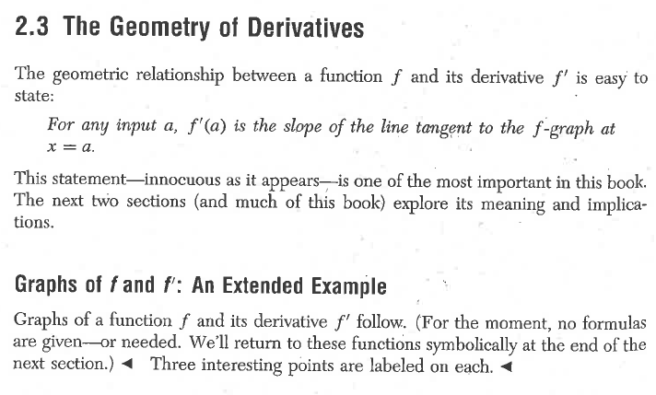

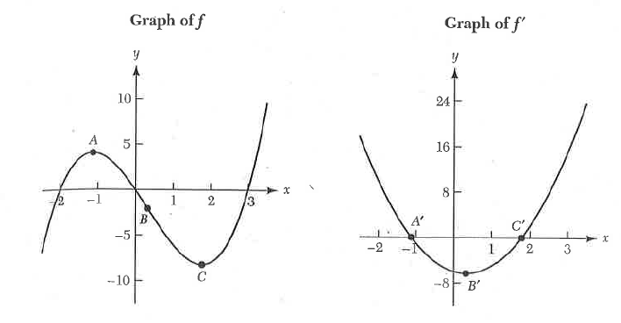

*Based on our prior learning, why are the points labeled on each graph “interesting”? How are the points A and C related to ? We will learn about the relationship between B and in just a wee bit . . .*

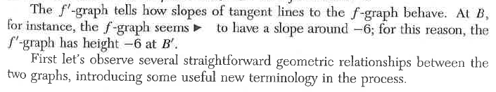

*Why does the graph of have a height of when the graph of f has a tangent line with a slope of ?*

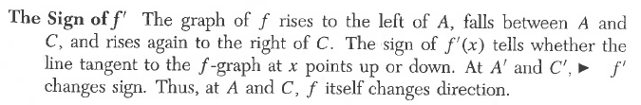

*Why does f change directions when changes sign? Explain in terms of the meaning of a derivative.*

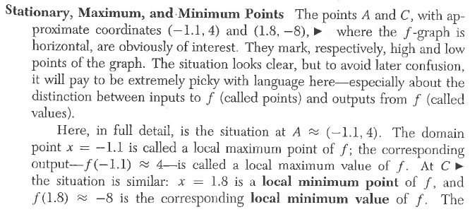

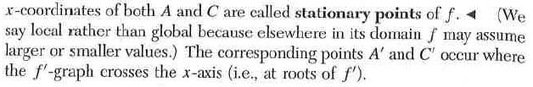

*What is the difference between a* ***local minimum point***  *and a* ***local minimum value****? Why do you think the author makes a point of being “picky” with the vocabulary?*

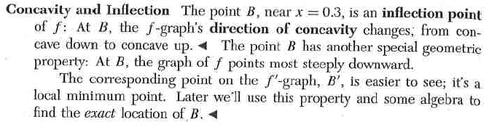

*One informal way to explain concavity is to think of concave up as where the graph “holds water” and concave down as where the graph “spills water”. Give a definition of concave up and concave down in your own words.*

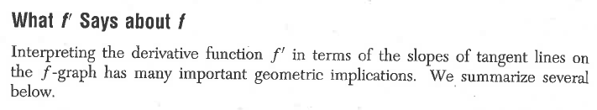

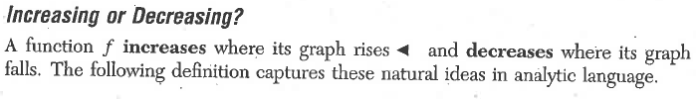

**Definition:** Let *I* denote the interval .

A function is **increasing** on *I* if 

A function is **decreasing** on *I* if 

*Explain what means.*

*Explain what and means.*

*In your own words, what does it mean for a graph to be increasing? For a graph to be decreasing?*

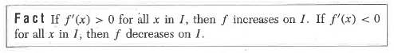

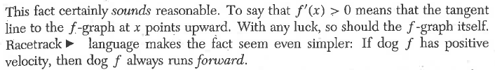

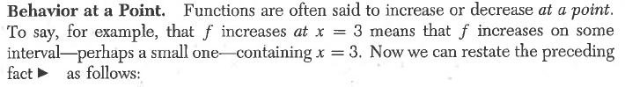

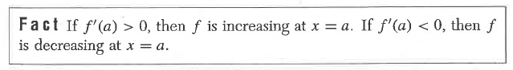



The converse of the above fact is as follows

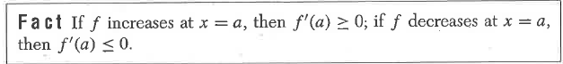

*Explain in your own words what the previous two “Facts” tell us about the relationship between the graph of a function and the graph of the functions derivative*.

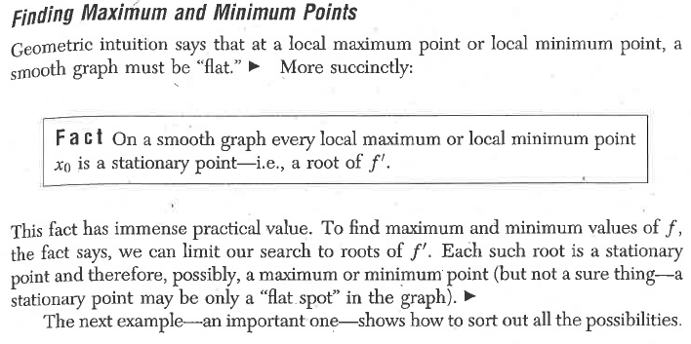

*Explain what the above “Fact” means in terms of finding local maximum/minimum points of graphs using the calculus we’ve learned.*

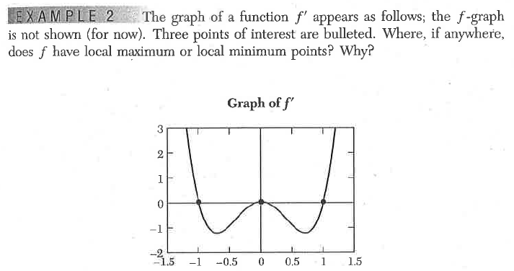

*What are the local minimum or maximum points? This is the same type of question that was on our last quiz.*

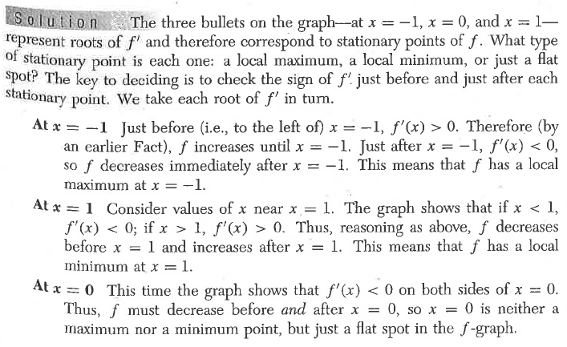

*Note above the explanation for why f does NOT have a local max/min at x = 0!! This is more in depth than we have looked in the past. Then explain, in your own words, what is happening to the graph of f at x = 0.*

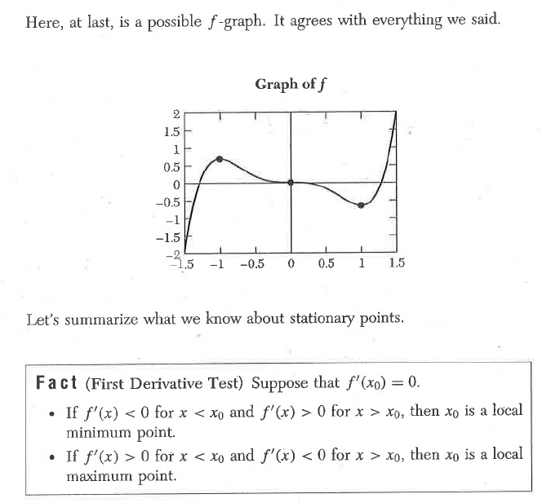

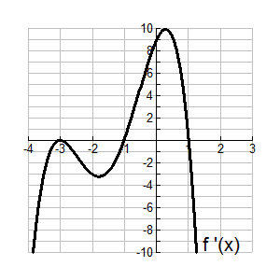**Practice:** Given the graph below of, find all the local maximum and minimum points of 

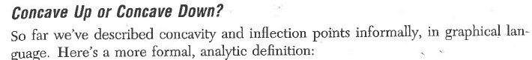

**Definition:** The graph of *f* is **concave up** at *x = a* if the derivative functionis increasing at *x = a*.

The graph of *f* is **concave down** at *x = a* ifis decreasing at *x = a*.

Any point at which a graph’s direction of concavity changes is called an **inflection point**.

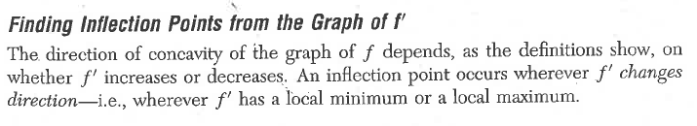

**Example:** When you take a calculus class, you will learn that the derivative of the sine function is the cosine function. That is, if , then . Based on this knowledge, discuss the concavity of the sine function. Find all inflection points and describe them in derivative language.

**Solution:** Note the graphs of andbelow.

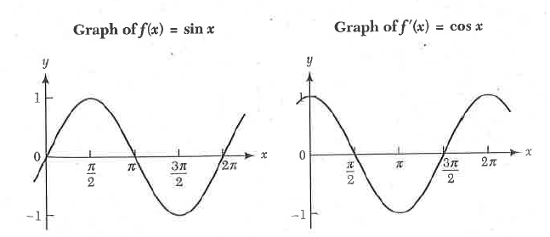

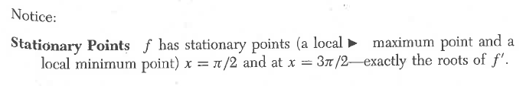

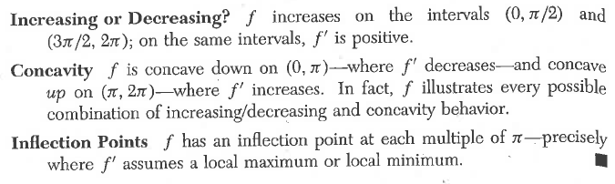

*Annotate (make notes on) the graphs above that illustrate the stationary points, increasing and decreasing intervals, concavity, and inflection points.*

*If has a local maximum or minimum, what is the value of?*

*Based on your answer to the above question, how can you find inflection points using the second derivative?*

*What do your inflection points tell you about the graph of f?*

**Practice:** The graphs of *f* andare reprinted below. They again illustrate the definition of concavity given above.

*Explain, referencing the labeled points on the above graphs, how the graph of illustrate the stationary points, increasing and decreasing intervals, concavity, and inflection points of the graph of f*.

*Fill in the below table based on what you have learned about the first and second derivative:*

**Conditions on the Description of Graph of**

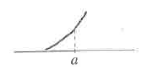**Derivatives  **

 

 

 

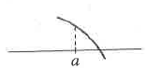

 

**Practice:** Sketch a graph of a functionwith all the following properties:

a. 

b. 

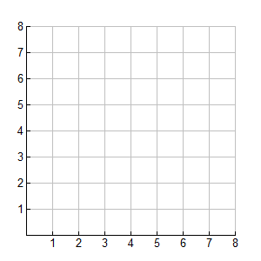c.

*Explain how the first derivative is related to the graph of *

*Explain how the second derivative is related to the graph of *

**Practice:** Sketch a graph of the function below. Label all relative/absolute maximums and minimums, points of inflection, and the *y*-intercept. Use your calculator ONLY FOR COMPUTATIONS No graphing! Use derivatives and show all work below. Pay attention to the scale of the axes.

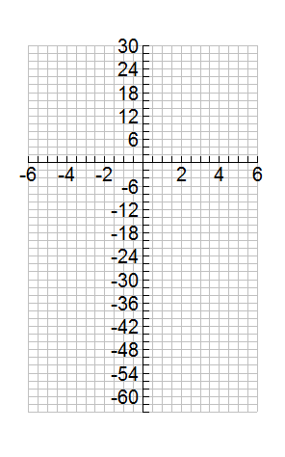



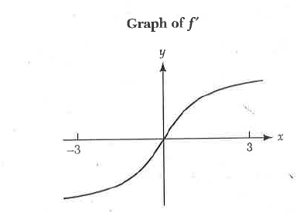**Practice (more difficult):** The graph of a derivative of the function *f* is shown.

a. The equation can have no more than two solutions on

the interval . Explain why.

b. Explain why *f* cannot have two zeros in the interval 

c. Suppose that. How many solutions does the equation

 have on the interval . Explain.

